Accessing Home Learning
We are using Microsoft Teams for our home learning. This is a step by step guide on how to access it.

- On a web browser (laptop or tablet), type and enter: gat.airhead.io
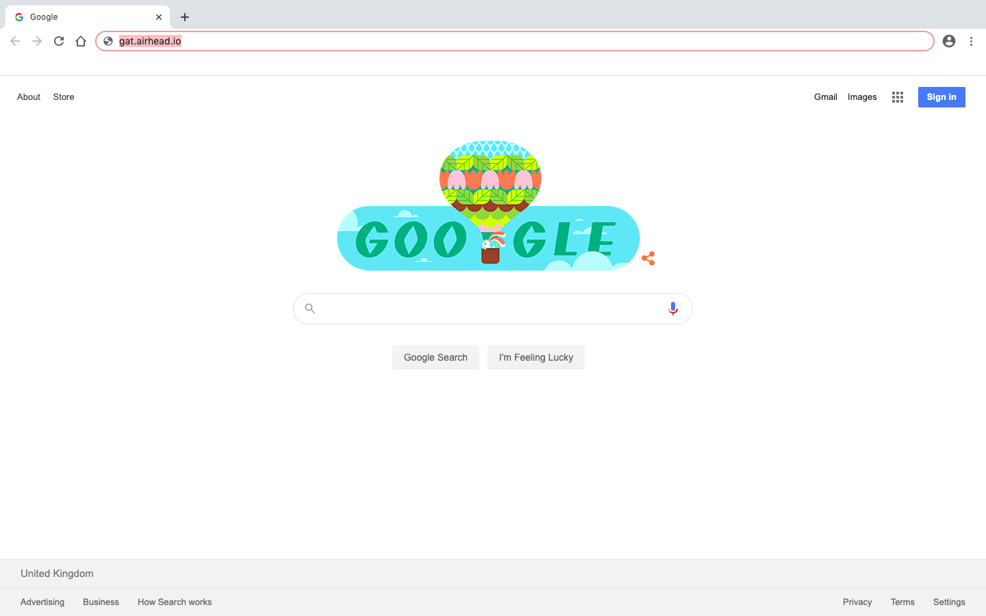

- You’ll arrive at this page, using your username card, enter your full email address, then press next.
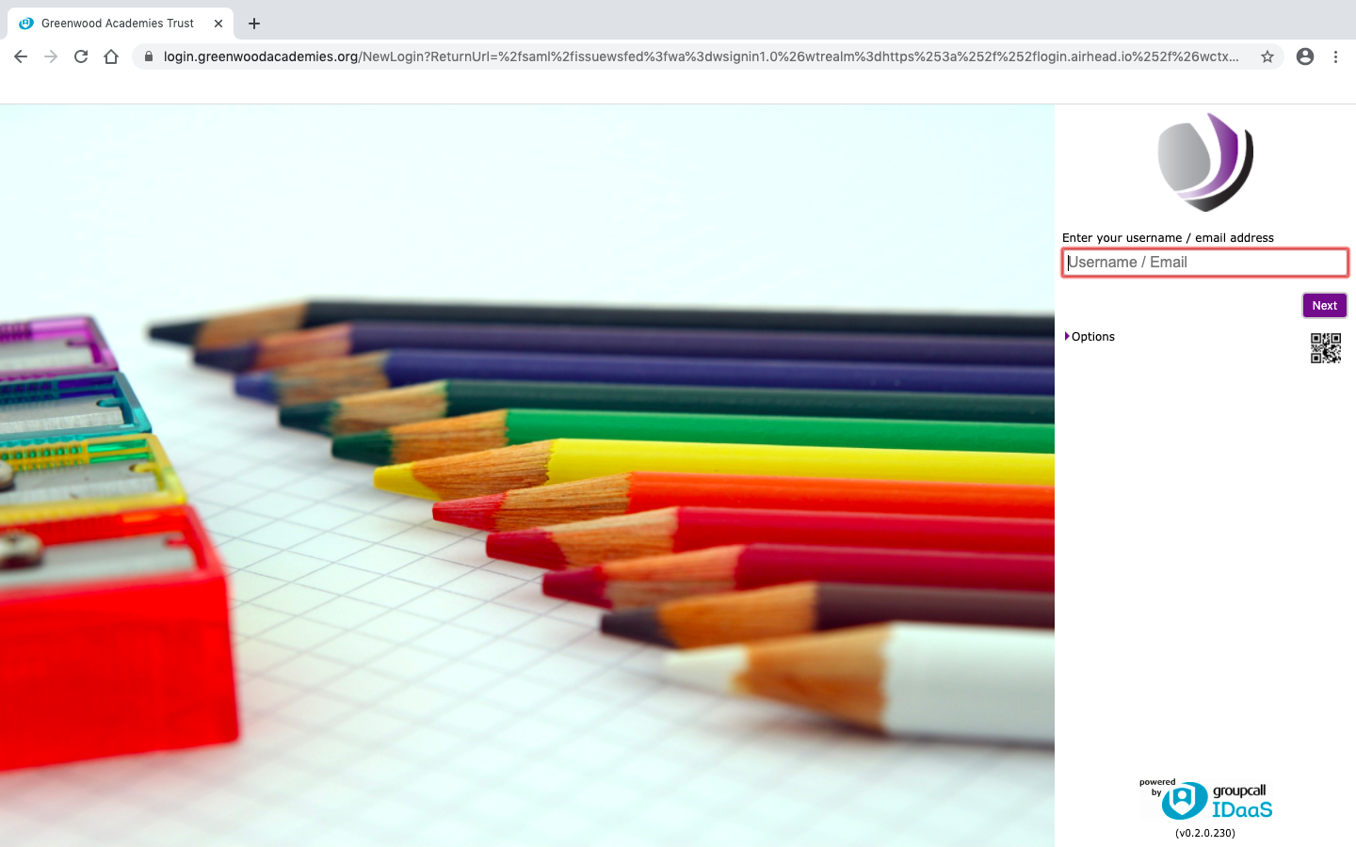
- You’ll then be prompted to enter your password, type it in and press login.
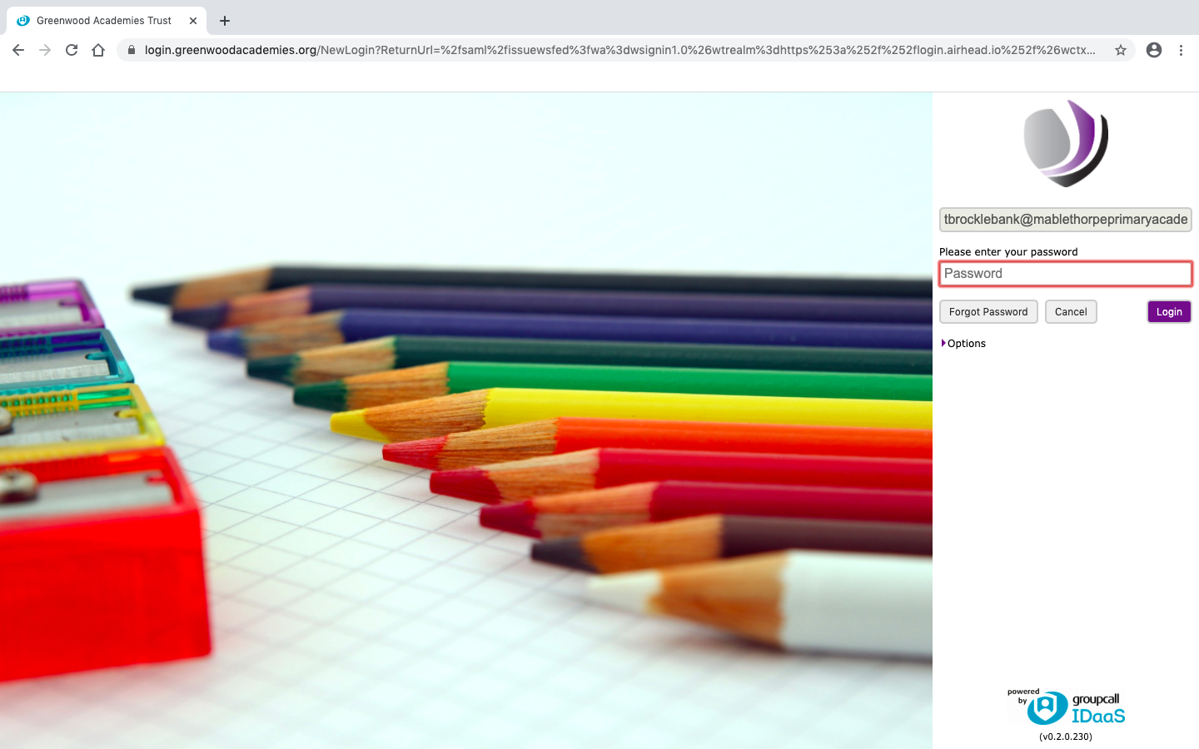

- You’ll then be asked to enter your details again.
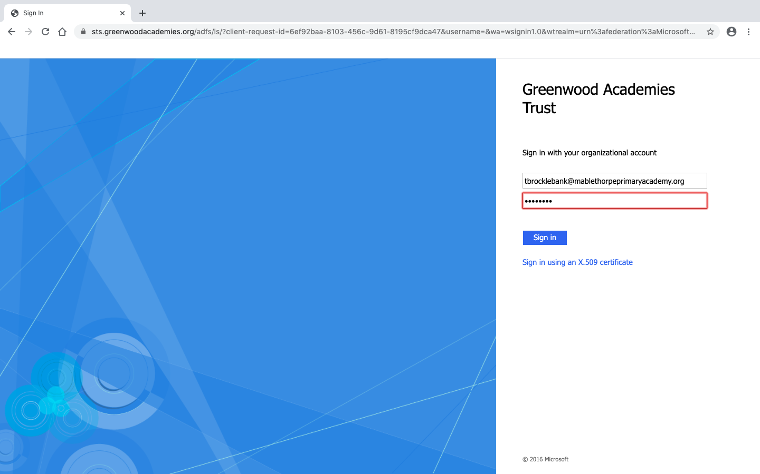

- You’ll be asked if you’d like to stay signed in, this will mean you’ll be able to log on quicker next time.
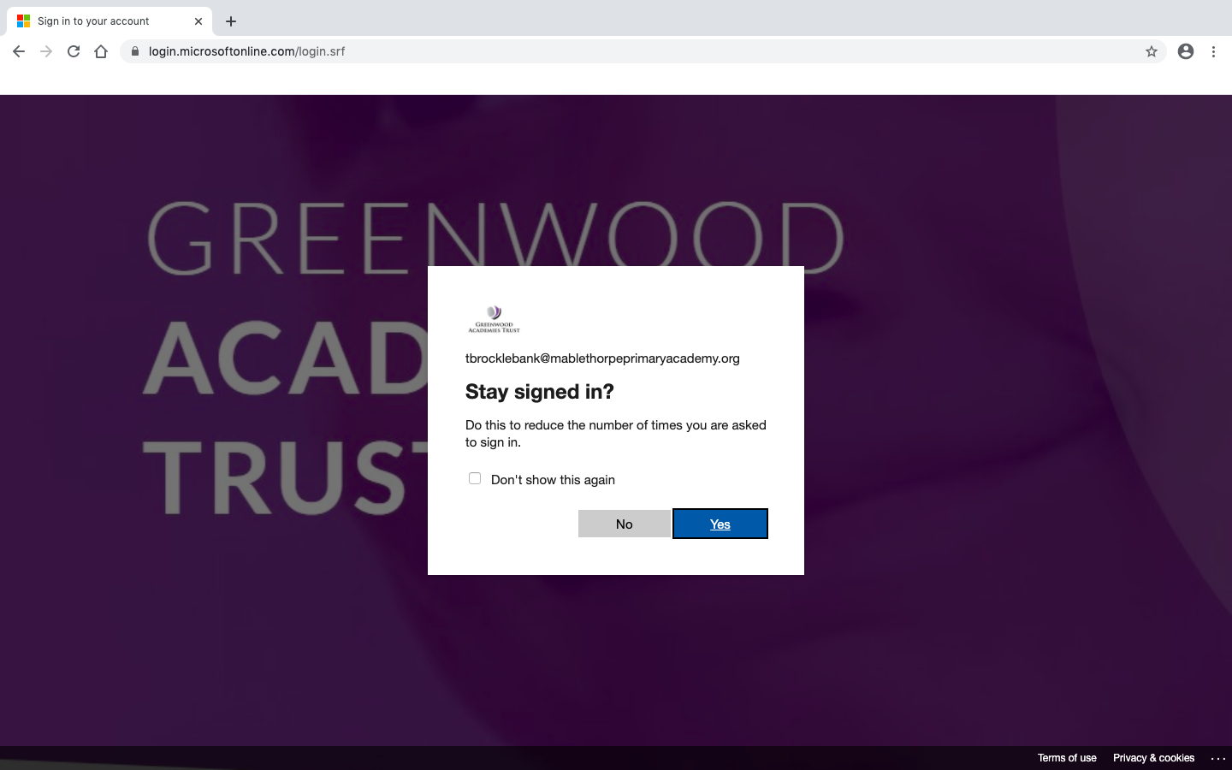

- Click through the help stuff…
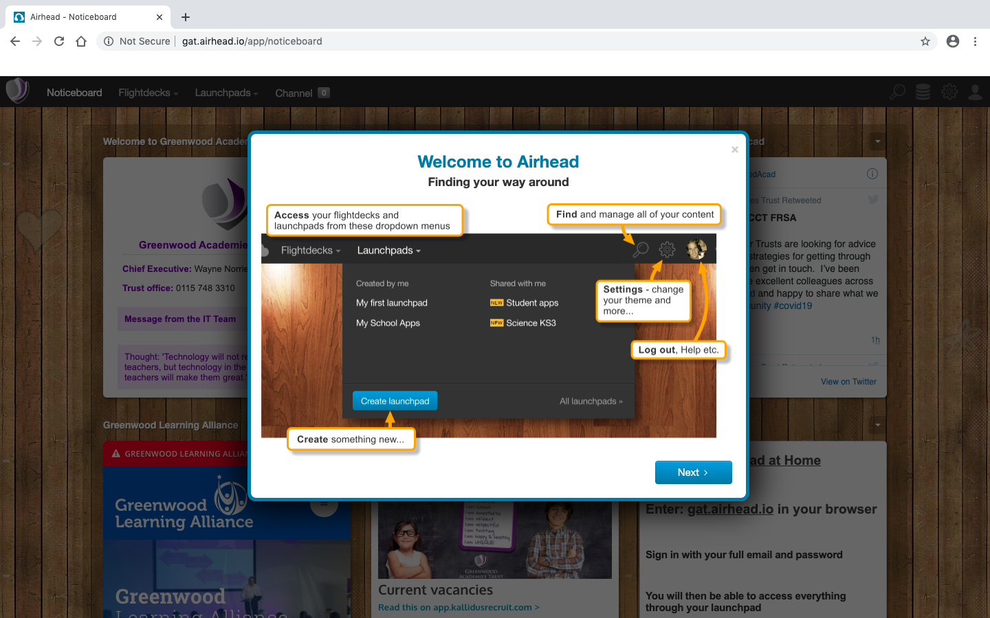

- This is the Airhead home page, it has announcements and updates from the GAT Twitter feed. Hover over ‘Launchpad’ at the top near the left.
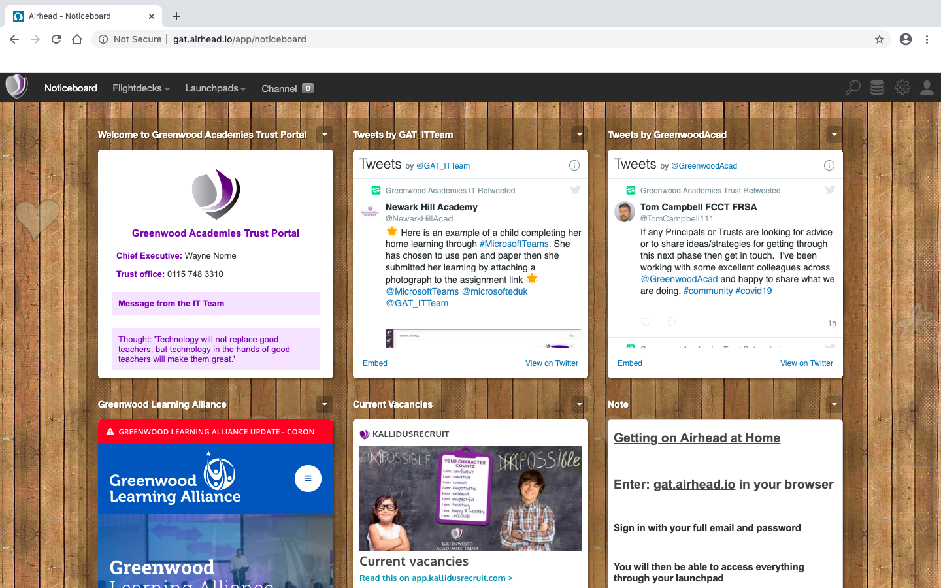

- Then in the ‘Shared with me’ section, click on ‘Computing for Students’.
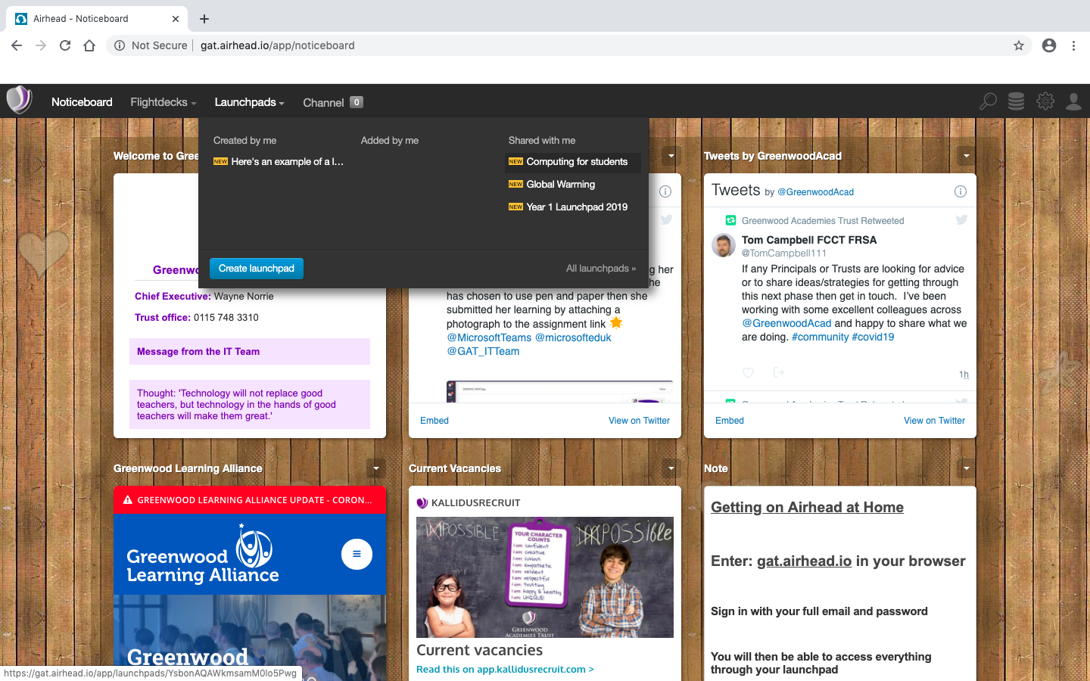

- This is the ‘Computing for Students’ Launchpad which has links to Microsoft Teams, the rest are links to computing activities that you can go on. For now, click on the Microsoft Teams link.
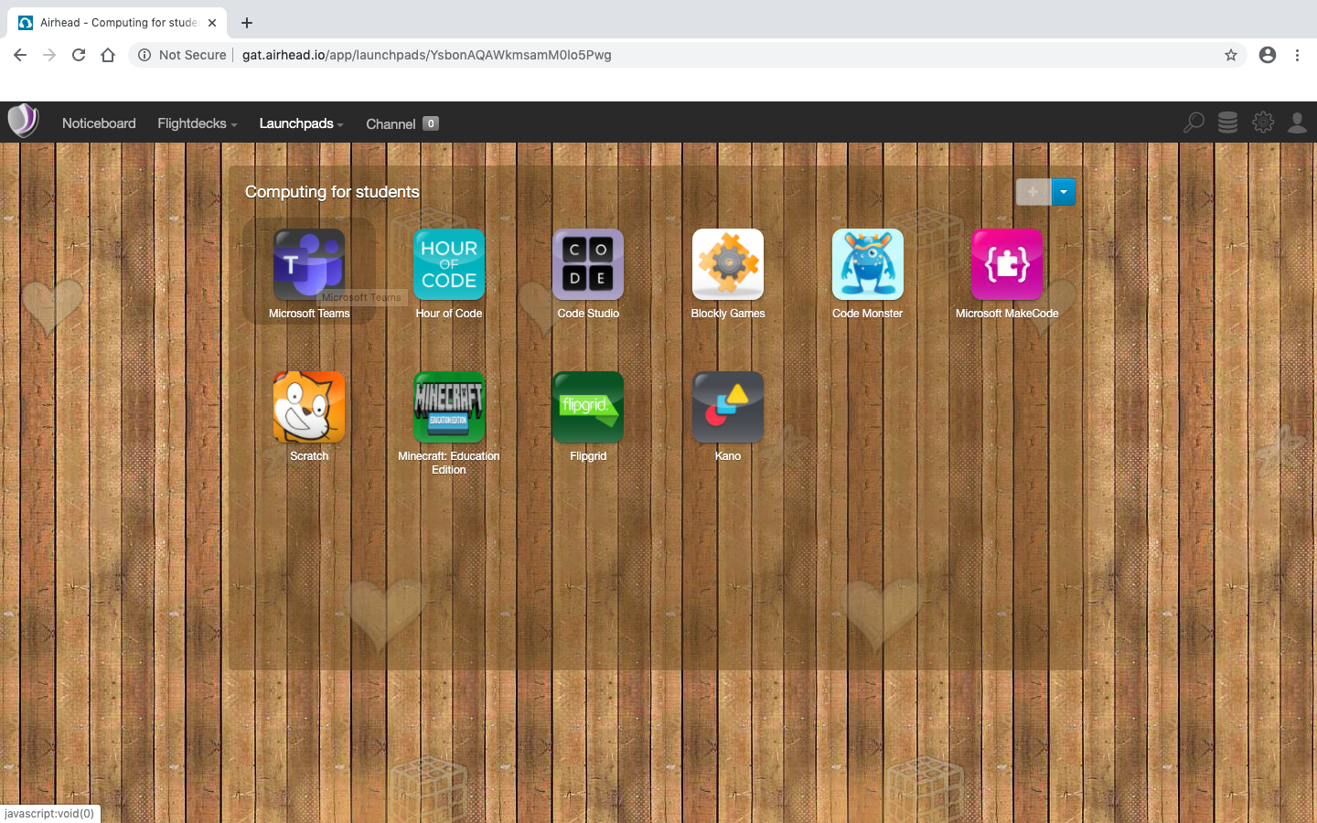

- You should be taken to your class section, click through all the help stuff again. The ‘Posts’ section is somewhere to chat with your class mates and teacher. Any inappropriate comments will be deleted and you could be banned from posting messages. Please use this section to ask for help and ideas with home learning. The ‘Class Notebook’ is a section for your teacher to put resources like hundred squares and word mats etc. For now, click on the ‘Assignments’ section.
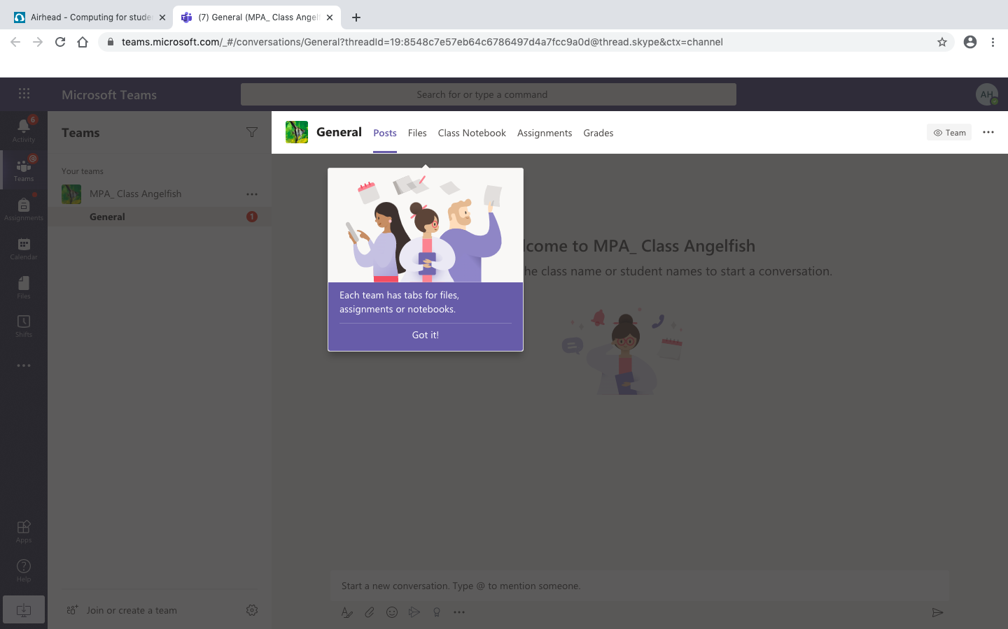
- Here will be any work that your teacher has set, here you can check the due dates. Choose an assignment and click on it.
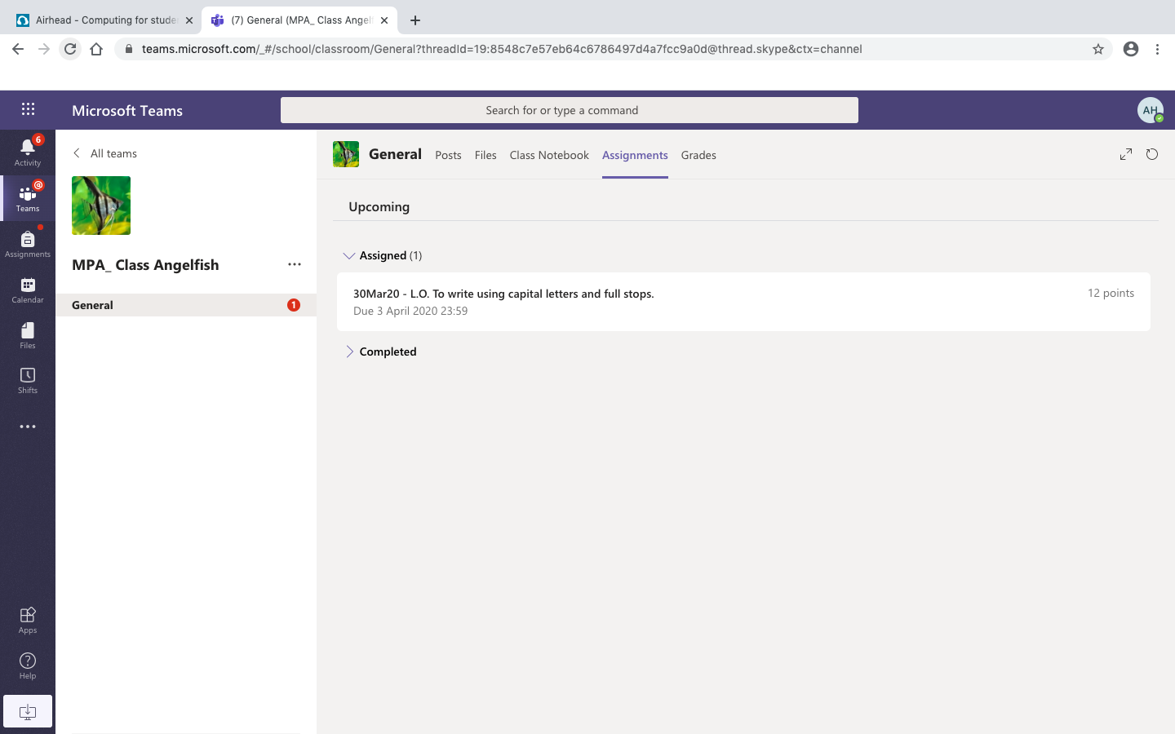

- You will see the title of the assignment, any instructions from your teacher, due date, points (if your teacher has chosen to offer them), and a section labelled ‘My Work’.
  - If your teacher has given you a document to complete your work on, click on that.
  - If they haven’t, you can click ‘+ Add work’ to attach anything such as photos of work if the work is practical or if you have hand written your work.
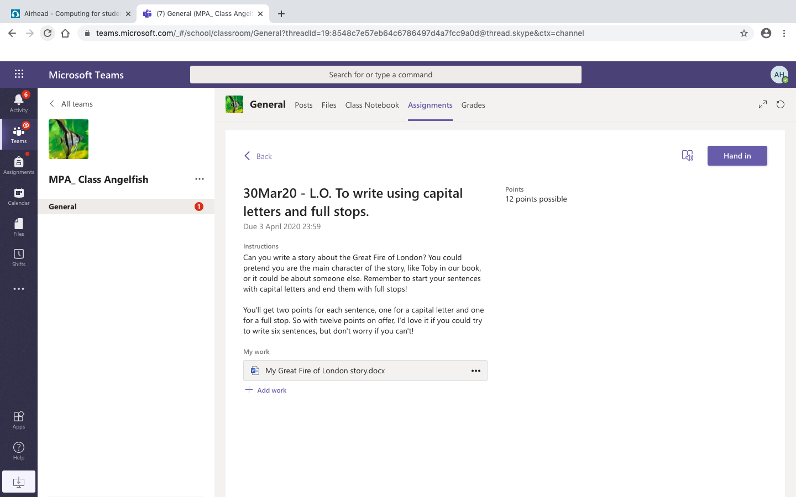
- If you’ve been given a Word document and you click on it, this will open up an editable document where you can type your work. You don’t need to save it as it’s Word Online, so it is saved automatically as you type. Once you’ve finished or if you’d like to leave it and come back to it later, click ‘Close’ in the top right corner.
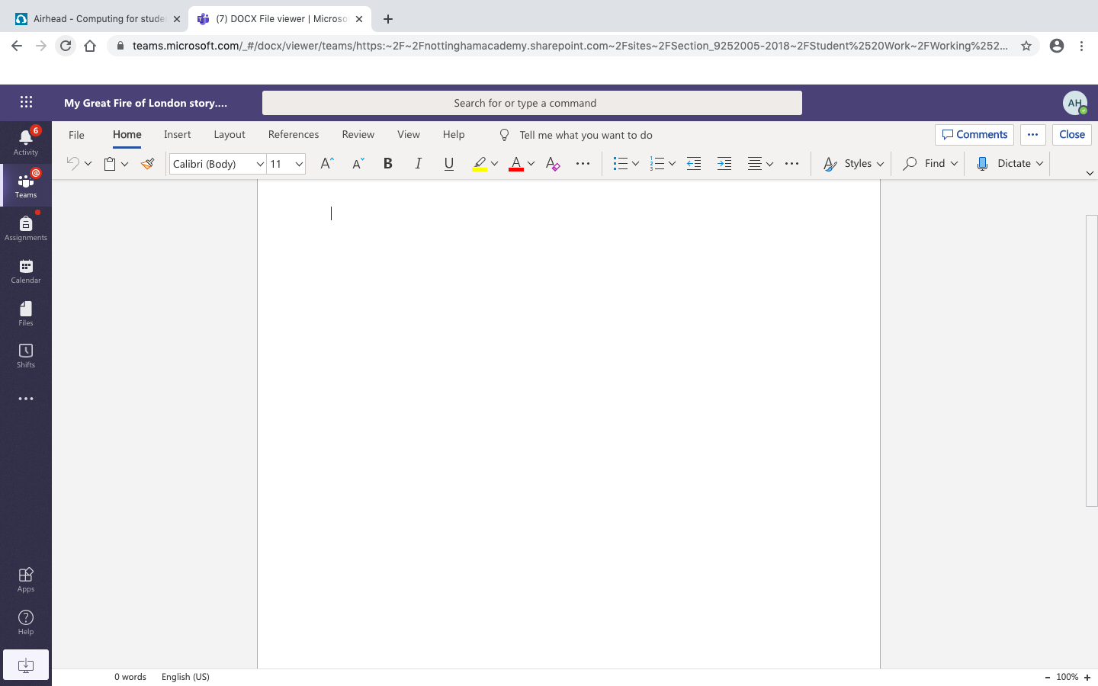
- This will take you back to the assignment page. If you’ve not finished the work and you’d like to come back to edit or add more, you can exit Teams. If you’re happy that you’ve completed the work fully, click ‘Hand in’ in the top right corner.


